**Collections Framework**

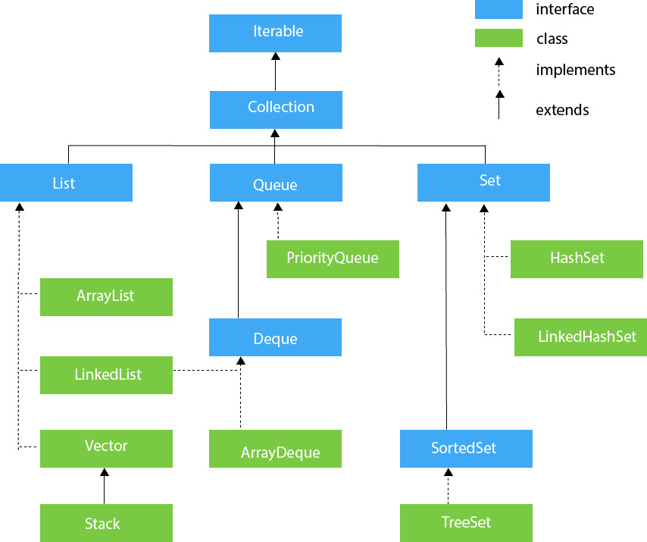

**Methods of Collection**

The Collection interface includes various methods that can be used to perform different operations on objects. These methods are available in all its subinterfaces.

* add() - inserts the specified element to the collection
* size() - returns the size of the collection
* remove() - removes the specified element from the collection
* iterator() - returns an iterator to access elements of the collection
* addAll() - adds all the elements of a specified collection to the collection
* removeAll() - removes all the elements of the specified collection from the collection
* clear() - removes all the elements of the collection

**Methods of List**

The List interface includes all the methods of the Collection interface. Its because Collection is a super interface of List.

Some of the commonly used methods of the Collection interface that's also available in the List interface are:

* add() - adds an element to a list
* addAll() - adds all elements of one list to another
* get() - helps to randomly access elements from lists
* iterator() - returns iterator object that can be used to sequentially access elements of lists
* set() - changes elements of lists
* remove() - removes an element from the list
* removeAll() - removes all the elements from the list
* clear() - removes all the elements from the list (more efficient than removeAll())
* size() - returns the length of lists
* toArray() - converts a list into an array
* contains() - returns true if a list contains specified element

**Methods of Queue**

The Queue interface includes all the methods of the Collection interface. It is because Collection is the super interface of Queue.

Some of the commonly used methods of the Queue interface are:

* **add()** - Inserts the specified element into the queue. If the task is successful, add() returns true, if not it throws an exception.
* **offer()** - Inserts the specified element into the queue. If the task is successful, offer() returns true, if not it returns false.
* **element()** - Returns the head of the queue. Throws an exception if the queue is empty.
* **peek()** - Returns the head of the queue. Returns null if the queue is empty.
* **remove()** - Returns and removes the head of the queue. Throws an exception if the queue is empty.
* **poll()** - Returns and removes the head of the queue. Returns null if the queue is empty.